**ModerateComment API Demo Screenshots:**

**1.** API called with an objectionable review text

*http://127.0.0.1:5000/reviews/A%20nigger%20recommended%20this.%20I%20should%20have%20known*

Response: “*Content Objectionable. Please Remove.”*

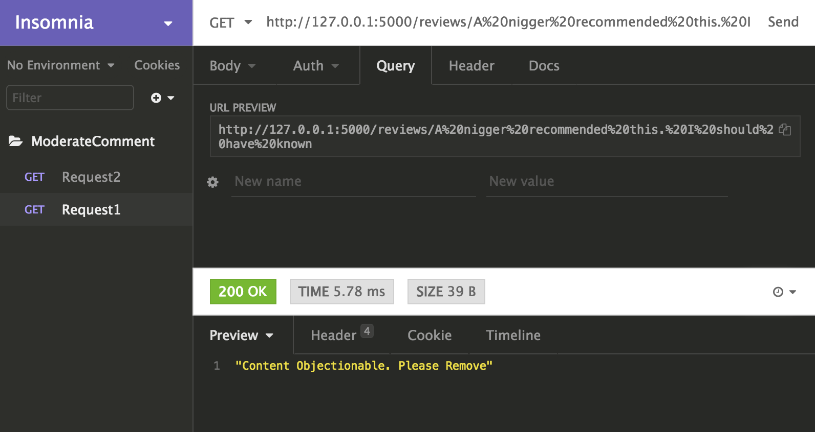

**2.** API called with a normal review text

*http://127.0.0.1:5000/reviews/Helped%20me%20a%20lot%20with%20household%20chores.%20Good%20quality!*

Response: *“Content OK”*

